Outlook Repair

Listed below are the steps required for repairing Microsoft Outlook.

1. Run Repair:
   1. Browse to Microsoft directory->Program Files (x86)->Microsoft Office
   2. Could be Office12 or Office14, doesn’t matter
2. Run the ScanPST file (icon looks like a torn letter).

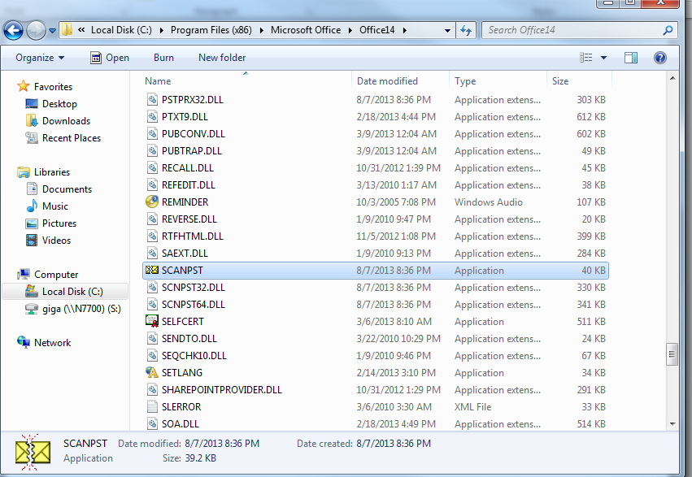

1. Browse for mail file.
2. Documents->Outlook Files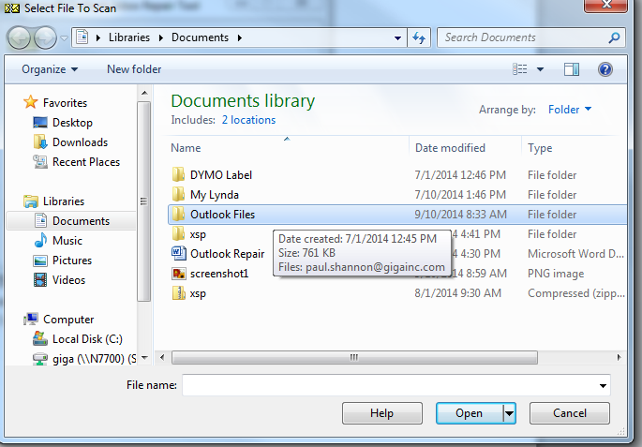

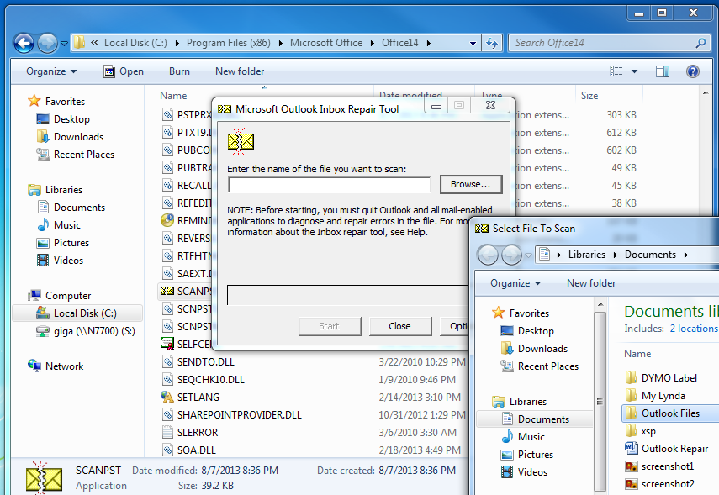

* 1. Scan->Start
     1. Make a copy on C:/Temp

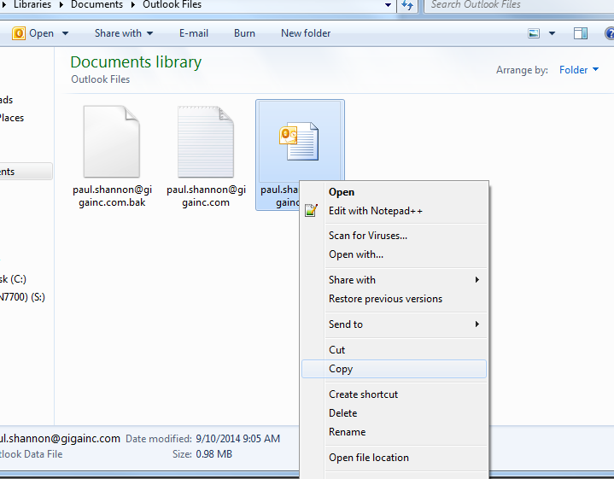

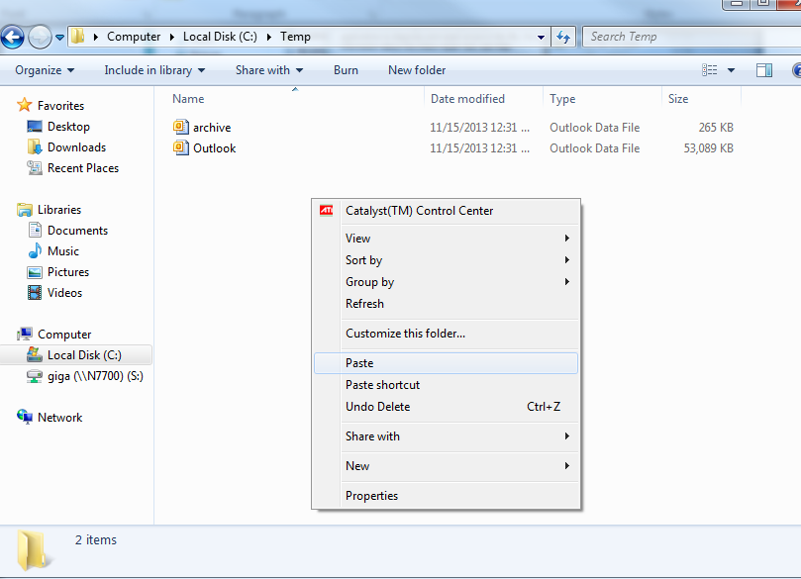

* + 1. Click Repair on the ScanPST application after scanning

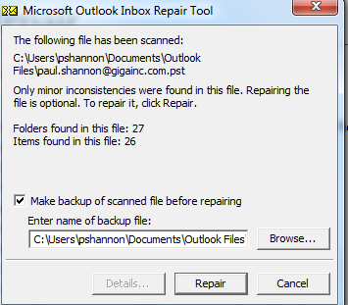

* + 1. Click OK

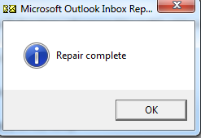

* + 1. Once the repair is complete, run it again from Step 4a (usually takes 2 to 3 runs, sometimes more—can take a long time, run it until there are NO error messages / until it says “no errors”)